Connect to AWS instance Via Putty

Host name : **ec2-13-235-255-149.ap-south-1.compute.amazonaws.com**

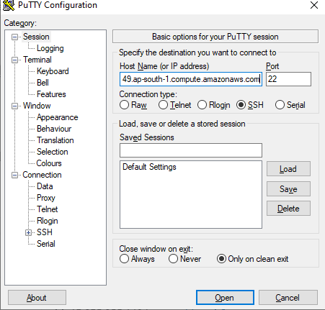

Save the attached .ppk file in your local drive

Navigate to SSH🡪 Auth and select the browse the locally saved .ppk file and open

Login with user name as ubuntu